Year 7 Problem Solving

- Manu was singing a song. It went "one, two, three, one, two, …"
What are the next three numbers?
What is the tenth number he’ll sing?

- I own 5 cars and a very large garage.
If I can see 2 cars parked outside the garage, how many are inside?

- Katie was given a marble on Tuesday.
Then she was given two marbles every day for a long time.
When did she get her 11th marble?

- Mrs Parore is hanging out her towels to dry.
She puts two pegs on each towel.
How many pegs does she need to hold 4 towels?
Mrs Parore sees that her peg box is running low.
She puts one peg on the corner of two towels.
This way she only needs 3 pegs for 2 towels.
How many pegs does she need for 4 towels now?

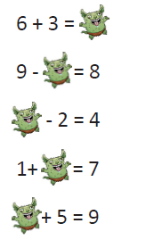
- Oh no, gremlins have been in and covered up some numbers on the chart.
Can you put the equations back together?

- Freddo wants to get out from the bottom of the well.
Each day, he climbs 3m up the wall of the well and then rests.
But the wall is slippery and he then slips down 1m.
The next day he does the same thing.
In fact he does this every day until he gets out of the well.
The well is 13m deep. How long does it take Freddo to climb out of the well?

